# Fundamentals of Data Base LAB

FAROOQ AHMAD Experiment # 1  
17L 4407 Lab Report # 1  
BEL – 8A1

## Intro to HTML

### INTRODUCTION

In this lab session, we were introduced to the basic HTML fundamental laws and rules. The Hyper Text Markup Language, or HTML(Hyper Text Markup Language) is the standard [markup language](https://en.wikipedia.org/wiki/Markup_language) for documents designed to be displayed in a [web browser](https://en.wikipedia.org/wiki/Web_browser). It can be assisted by technologies such as [Cascading Style Sheets](https://en.wikipedia.org/wiki/Cascading_Style_Sheets) (CSS) and [scripting languages](https://en.wikipedia.org/wiki/Scripting_language) such as [JavaScript](https://en.wikipedia.org/wiki/JavaScript).

[Web browsers](https://en.wikipedia.org/wiki/Web_browser) receive HTML documents from a [web server](https://en.wikipedia.org/wiki/Web_server) or from local storage and [render](https://en.wikipedia.org/wiki/Browser_engine) the documents into multimedia web pages. HTML describes the structure of a [web page](https://en.wikipedia.org/wiki/Web_page) [semantically](https://en.wikipedia.org/wiki/Semantic_Web) and originally included cues for the appearance of the document.

This lab was a detailed explanation of the elementary html terms including

**HTML Tags**

**Web Browsers**

**HTML Element**

**HTML Headings**

**HTML Paragraphs**

**HTML Lists**

**HTML Images**

**HTML Links**

**Using Images as HTML Links**

**Linking Within a Single Page**

**HTML Tables**

**INPUT Control**

Using all of these commands, we were assigned to build up a webpage using html.

### OBJECTIVE

The course learning objective of this lab session was the Introduction to HTML language.

### PROCEDURE

## Exercise 1: Create a first page “firstpage.html”

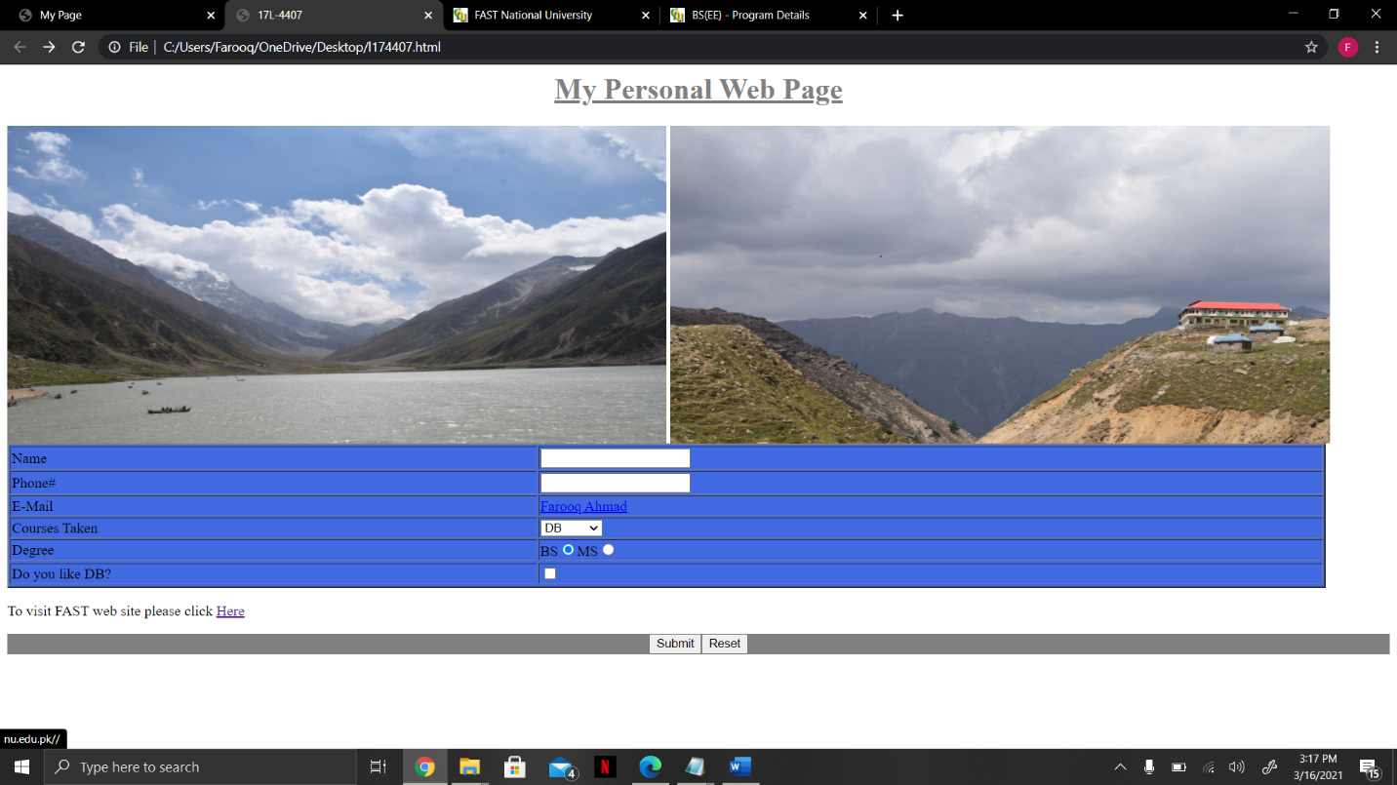

CODE :

<html>

<head>

<title> 17L-4407 </title>

</head>

<body>

<h1 style="color:grey;" align="center" > <u>My Personal Web Page </u></h1>

<a href="http://nu.edu.pk//" target="_blank"><img src="DSC_0078.jpg" width="725" height="350" align="center"></a>

<a href="http://nu.edu.pk/Program/BS(EE)/" target="_blank"><img src="D:\100D5300\DSC_0079.jpg" width="725" height="350" align="center"></a>

</br>

<table border="2" style="background-color:#4169E1" width="1450">

<tr>

<td>Name</td>

<td><input id="Text1" type="text" /></td>

</tr>

<tr>

<td>Phone#</td>

<td><input id="Text1" type="text" /></th>

</tr>

<tr>

<td>E-Mail</td>

<td><a href="l174407@lhr.nu.edu.pk">Farooq Ahmad</a></td>

</tr>

<tr>

<td>Courses Taken</td>

<td><select name="courses" id="courses">

<option value="DB">DB</option>

<option value="DB Lab">DB Lab</option>

<option value="ES">ES</option>

<option value="ES Lab">ES Lab</option> </td>

</tr>

<tr>

<td>Degree</td>

<td>BS<input id="Radio1" type="radio" checked="true" />MS<input id="Radio2" type="radio" /></td>

</tr>

<tr>

<tr>

<td>Do you like DB?</td>

<td><input id="Checkbox1" type="checkbox" /></td>

</tr>

<tr>

</table>

<p> To visit FAST web site please click <a href="http://nu.edu.pk/"target="_blank">Here</a> </p

</br>

<p style="background-color:#808080" align="center"><input id="Button1" type="button" value="Submit" /><input id="Button2" type="button" value="Reset" /> </p

</br>

</body>

</html>

### ISSUES

There were no issues.

### CONCLUSION

We were introduced to the hyper text markup language or the html very well and it was taught how to develop a web page using purely html commands and prompts. [HTML elements](https://en.wikipedia.org/wiki/HTML_element) are the building blocks of HTML pages. With HTML constructs, [images](https://en.wikipedia.org/wiki/HTML_element#Images_and_objects) and other objects such as [interactive forms](https://en.wikipedia.org/wiki/Fieldset) may be embedded into the rendered page. HTML provides a means to create [structured documents](https://en.wikipedia.org/wiki/Structured_document) by denoting structural [semantics](https://en.wikipedia.org/wiki/Semantics) for text such as headings, paragraphs, lists, [links](https://en.wikipedia.org/wiki/Hyperlink), quotes and other items. HTML elements are delineated by *tags*, written using [angle brackets](https://en.wikipedia.org/wiki/Bracket#Angle_brackets). Tags such as <img /> and <input /> directly introduce content into the page. Other tags such as <p> surround and provide information about document text and may include other tags as sub-elements. Browsers do not display the HTML tags, but use them to interpret the content of the page.

### APPLICATIONS

HTML is one of the most widely used language over the web, list of a few of them:

* Web pages development - HTML is used to create pages which are rendered over the web. Almost every page of web is having html tags in it to render its details in browser.
* Internet Navigation - HTML provides tags which are used to navigate from one page to another and is heavily used in internet navigation.
* Responsive UI - HTML pages now-a-days works well on all platform, mobile, tabs, desktop or laptops owing to responsive design strategy.
* Offline support HTML pages once loaded can be made available offline on the machine without any need of internet.
* Game development- HTML5 has native support for rich experience and is now useful in gaming development arena as well.

### POSTLAB

1. Design a webpage for a sports website using HTML only. Use your imagination and be innovative. For help explore w3schools.

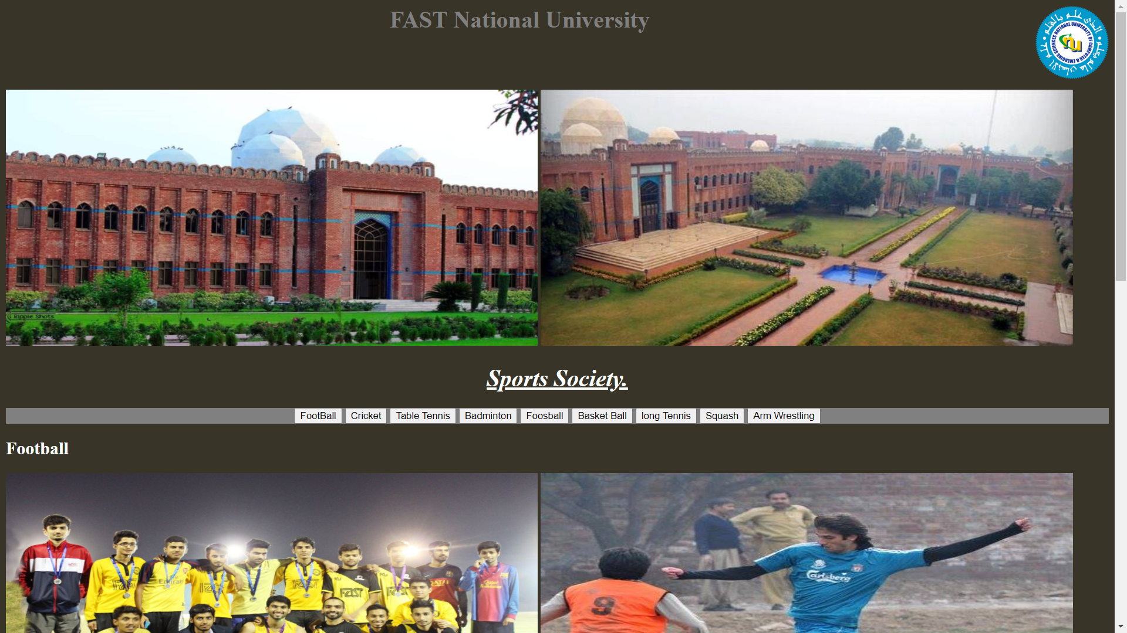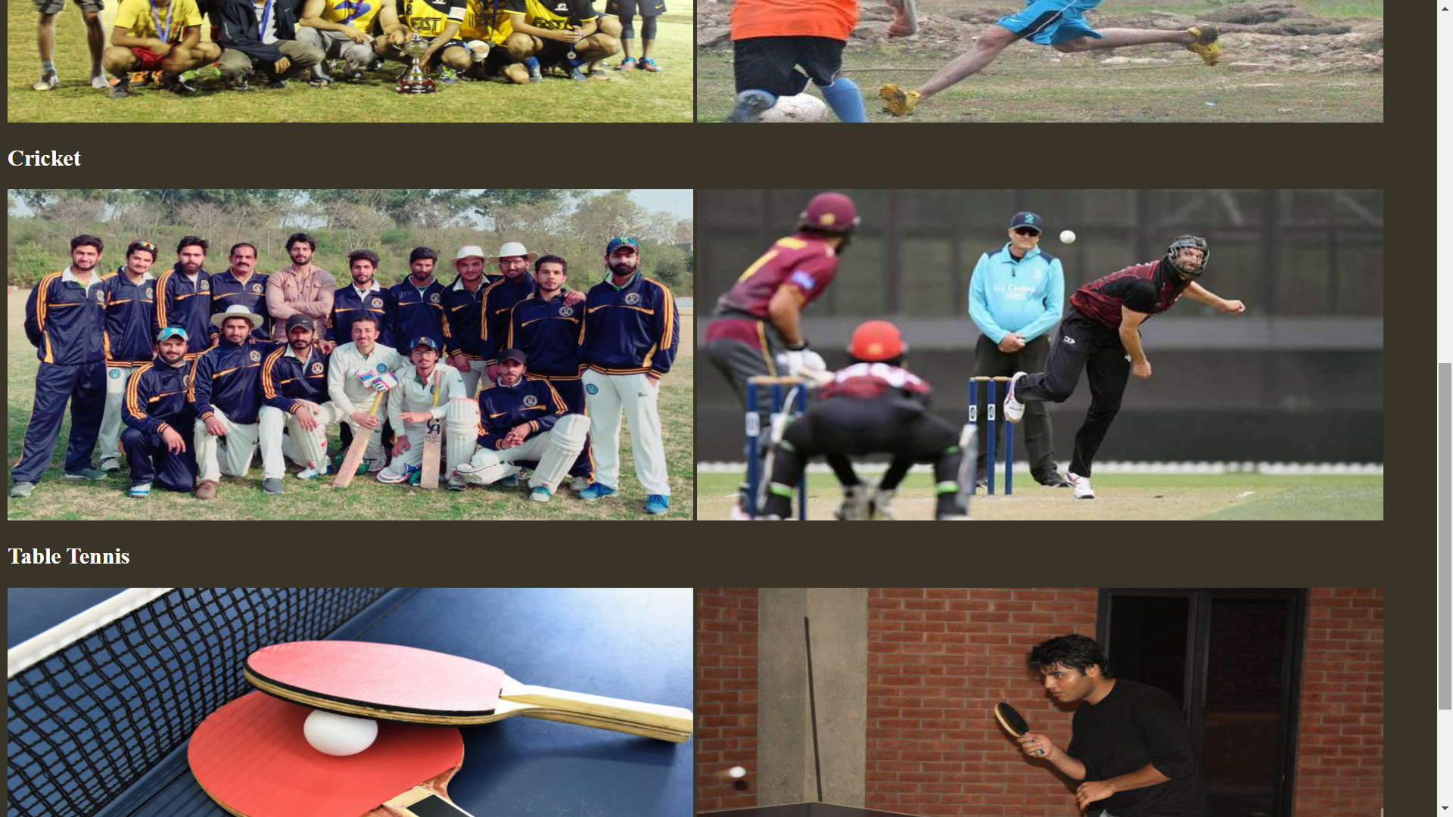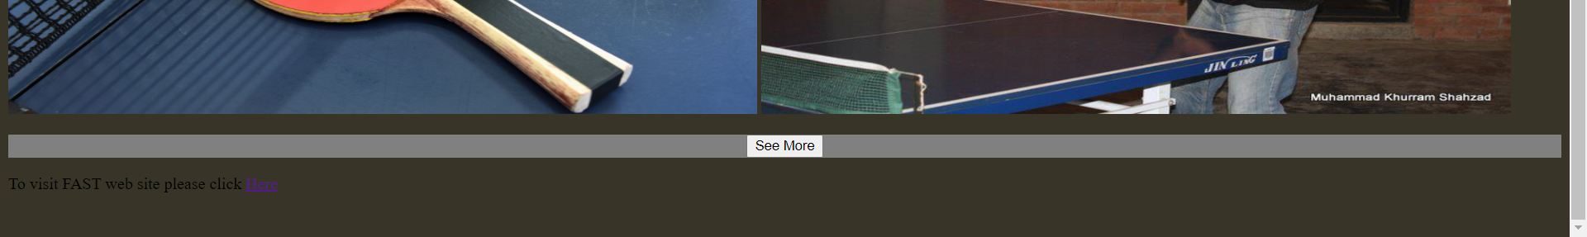

CODE :

<html>

<head>

<title> Postlab1 17L-4407 </title>

</head>

<body style="background-color:#383428;">

<h1 style="color:grey;" align="center" > FAST National University <img src="fast.png" width="100" height="100" align="right"></h1>

</br>

</br>

</br>

<a href="http://nu.edu.pk//" target="_blank"><img src="fast-nu.jpg" width="725" height="350" ></a>

<a href="http://nu.edu.pk/Program/BS(EE)/" target="_blank"> <img src="fastnu.jpg" width="725" height="350" ></a>

</br>

<h1 style="color:white;" align="center" > <i><u>Sports Society. </i> </u> </h1>

<p style="background-color:#808080" align="center">

<input id="Button1" type="button" value="FootBall" />

<input id="Button1" type="button" value="Cricket" />

<input id="Button1" type="button" value="Table Tennis" />

<input id="Button1" type="button" value="Badminton" />

<input id="Button2" type="button" value="Foosball" />

<input id="Button1" type="button" value="Basket Ball" />

<input id="Button1" type="button" value="long Tennis" />

<input id="Button1" type="button" value="Squash" />

<input id="Button1" type="button" value="Arm Wrestling" />

</p>

<h2 style="color:white;" >Football </h2>

<img src="football1.jpg" width="725" height="350" >

<img src="football2.jpg" width="725" height="350" >

</br>

<h2 style="color:white;"> Cricket </h2>

<img src= "cricket1.jpg" width="725" height="350" >

<img src= "cricket2.jpg" width="725" height="350" >

</br>

<h2 style="color:white;"> Table Tennis </h2>

<img src= "tt1.jpg" width="725" height="350" >

<img src= "tt2.jpg" width="725" height="350" >

<p style="background-color:#808080" align="center"><input id="Button1" type="button" value="See More" /></p>

<p> To visit FAST web site please click <a href="http://nu.edu.pk/"target="_blank">Here</a> </p

</br>

</br>

</body>

</html>

1. Find and list the differences between HTML version 3 and HTML version 5.

HTML3.0 builds up on HTML2.0. It’s new abilities promised to be more powerful for web designers so they can have the ability to further enhance their websites. HTML3.0 is a RISC OS only macro inserter for creating web pages and instead of giving you full editing facilities, it allows you to use text editor and types all the commands you need into the keyboard for you.

HTML3 can help you do different things for your website; you can create headers, including all the meta tags you’ll need to get it seen on search engines, a graphical document color picker so you can see how the colors work together, footers, text effects with 16 color palette editor, links with JavaScript rollover and description functions and many other stuff.

The way HTML3 was created was to allow to be used in a variety of ways. It is simple enough to type it by hand, authored using WYSIWYG editors for HTML or it can be generated via export filters.

On the other hand, HTML5 strives to be something very different. It aims to be more of an application development platform which not only includes laying out text and images, but it also includes playing video and audio, interactive 2D and 3D graphics, storing data in the application, dealing with online and offline access to data and real-time networking protocols. The aim of this latest version is to improve the language support of latest multimedia while keeping it user friendly, easily readable and understood by computers. These new features allow for developers to write more sophisticated and descriptive client-side code. If you want to understand a little bit more about HTML5 you can take a look at Booklock, an app developed by us using HTML5 compiled for iOS.

It is perfectly acceptable to keep using HTML3 even though a new and improved version already exists. The problem is that the sophisticated code used in HTML5 becomes the standard one so eventually previous versions become outdated for new versions of browsers, new computers, smartphones…etc.